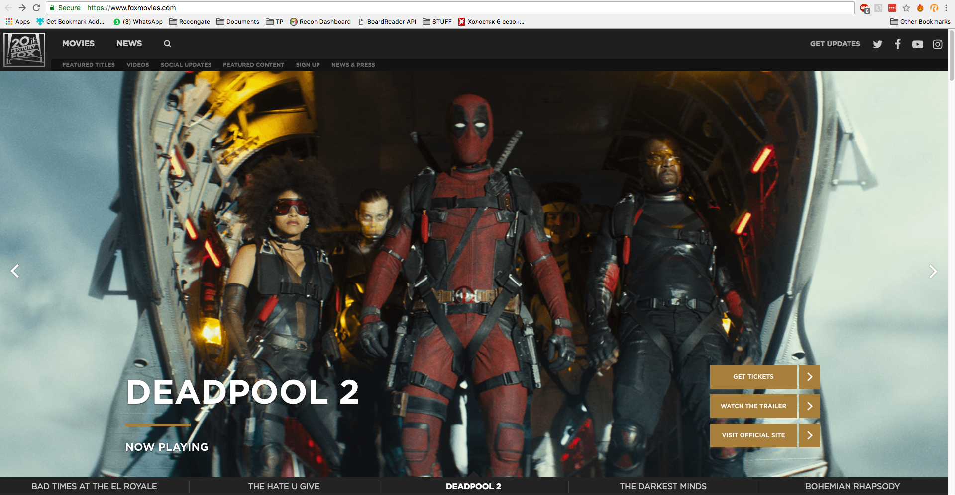

Movie Theater Delight

Recongate - Frontend challenge

**─**

Danny Zarko

VP R&D

[danny@recongate.com](mailto:danny@recongate.com) | 0524866888

# 

# Overview

Good functional programming skills and an overall sense of fineness is what you will need to successfully complete this web-component Jem.

To see it in action go to: <http://www.foxmovies.com/>

# Exercise

The end result should be similar to what you see on the fox website.

Upload at least 6 images.

Underneath the image carousel should be a separated image carousel containing the title of each image.

Clicking on an image name on the secondary carousel should slide the main carousel.

The image sliding on the main carousel should be similar as on the website.

The images should be looped - i.e no “last” image

# Goals

1. Use React - <https://egghead.io/courses/react-fundamentals>
2. Make it look good
3. Make it work smoothly
4. Write a readable and well structured code
5. **Please make sure no to use pre-build components for the image slider**

# Pointers

1. Pay attention to design details
   1. Transitions / animations
   2. Overall behaviour
2. Use css flexbox attributes for layouting ([see here](https://css-tricks.com/snippets/css/a-guide-to-flexbox/)) ([flex-box generator](http://the-echoplex.net/flexyboxes/))
3. Be efficient with your html css and try to avoid redundant elements

# Milestones

## Infra

Create a **json** file for your data and call it with an **API** request to your local directory

Create a **small React Project** and take a minute to think about your project’s architecture ([you can use a yeoman generator](http://yeoman.io/generators/))

## Make it look Good (HTML CSS)

After reading the data from the json file, style your component while keeping in mind that we value your accuracy in implementing a design.

## Make it work Smoothly

Write the necessary functionality to complete the component’s behaviour (like on the fox website)

## Final Touch

Finally go over your work and pay attention to transitions / animations.

Upload project to github and send us the link :-)

Good Luck!